REPORT ON 26/2/2019

**MY STUDY EXPERIENCE FOR THE LAST THREE WEEKS**

The units we study are; Hardware Electronics, Hardware Design, Mobile, Graphic Design, HTML CSS,

Python, Life Skills, Entrepreneurship, Introduction to computers, and JavaScript.

HARDWARE DESIGN

We have been taught; Introduction to production design and design processes. 

Stages of product design.

Design thinking.

HARDWARE ELECTRONICS

We have been taught; electric current, ampere, resistance, and voltage.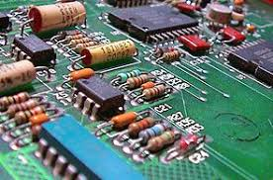

GRAPHIC DESIGN

We have been taught; painting, drawing symbols, and drawing curves and shapes on computer.­­-­-­- 

ENTREPRENEURSHIP

We have been taught; introduction to entrepreneurship, types of entrepreneurs, companies.

LIFE SKILLS

We have been taught; personal fulfilment, review of last year, building the future.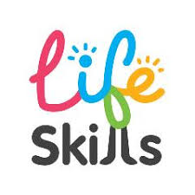

INTRODUCTION TO COMPUTERS

We have been taught; emails, retrieving unsaved documents, command prompt, and typing.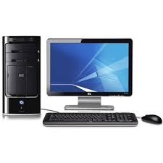

HTML CSS

We have been taught; introduction to html, html tags, using html tags.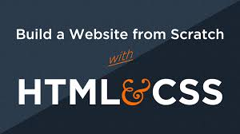

PYTHON

We have been taught; applications that use python, variables, strings and arithmetic.

We have not yet been taught JavaScript and mobile development. The difficult units are Graphic Design, Python, and electronics.

Report done by; Edith Jepleting.